Cardio Vs. Weightlifting: What's Better for Weight Loss?

Meta Description | What’s better for weight loss, cardio or weightlifting? Planning an exercise routine after bariatric surgery can be hard. Learn what exercises to include.
Keywords | Cardio vs weightlifting, cardio vs strength training, cardio or weightlifting weight loss, cardio or weightlifting bariatric surgery, cardio weight lifting better for weight loss, cardio for weight loss
Alt Tags | Adult woman with smartwatch sits on floor at home and adjusts weights
 | 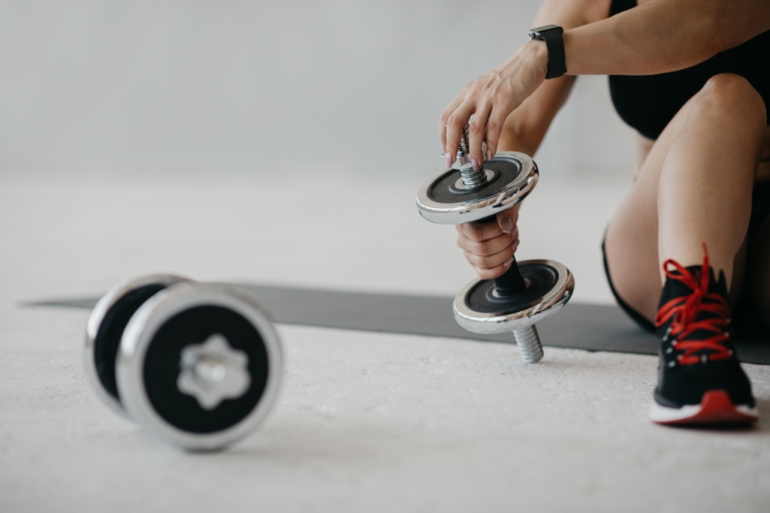
Image Link | https://elements.envato.com/training-for-biceps-adult-woman-with-smartwatch-si-7SSVDEY

After your Lap-Band® surgery, exercise will become an important component of your weight-loss journey. The most important aspect to losing weight is the assistance from the Lap-Band to help limit your food intake and promote your feeling of fullness, healthy eating, and controlled portions. However, exercise can help build muscle and maintain your level of weight loss. In addition, regular exercise can offer plenty of other health benefits, including improving cardiac health, lung capacity, and even reducing the need for those suffering from type 2 diabetes.

All that said, especially if you’re new to working out, developing an exercise routine can be difficult. For those post-surgery, a common question is the type of exercise they should be focus on to assist in their weight-loss journey: cardio or weightlifting?

Cardio Improves Your Health After Bariatric Surgery

Cardiovascular activities, like running, biking, swimming, walking, and climbing, burn a high number of calories. When compared to weightlifting for the same time commitment, cardio will burn more calories during your exercise session. In combination with healthy food choices, cardiovascular exercise is especially helpful for those trying to lose weight—the more you weigh, the more calories you burn during cardio.

Cardio also has several additional health benefits, which can help reduce or prevent obesity-related comorbidities. These benefits include improving your hearth health, lowering your blood pressure, and boosting your immune system. Because cardio forces your lungs to work harder to provide oxygen, it also strengthens your respiratory function.

High-Intensity Interval Training
High-intensity interval training (HIIT) is a type of workout that alternates periods of intense exercise with periods of rest. By ramping up the intensity of your workout for a short time, HIIT workouts can help you burn the same number of calories as traditional cardio in a shorter amount of time. This makes HIIT ideal for Lap-Band patients who lead busy schedules and want to squeeze in a workout whenever they can.

Weightlifting Helps Build Muscle After Weight-Loss Surgery

Strength training activities, also called weight training or resistance training, might include free weights or weight machines. Weight training may burn fewer calories during your workout, but it has a few distinct benefits. In tandem with protein-providing foods, weightlifting helps change your body composition, decreasing fat and increasing muscle. While the Lap-Band Program results in a lower likelihood of loose skin due to gradual weight loss, strength training can help further fill out loose skin.

Building muscle increases your resting metabolism and your basal metabolic rate (BMR), which is the number of calories you burn by performing basic vital functions. While cardio burns more calories during the workout, strength training also causes you to continue burning calories after you stop working out.

Like cardio, weight training also helps improve your hearth health by lowering your blood pressure and LDL cholesterol. Additionally, the temporary pressure during weightlifting helps you build stronger bones. This increased bone strength, along with a higher level of muscle, lowers your risk of dangerous falls and injury, both in everyday life and during exercise.

Cardio and Weightlifting After Your Lap-Band Procedure

So, what’s better for improving your health and assisting with weight loss after your Lap-Band procedure, cardio or weightlifting?

Depending on your overall goals, you should incorporate cardio and strength training activities into your workout routine to reap the benefits of both. Not only can both help you lose weight, but they can help you make essential improvements to your overall health.

However, note that exercise is just one component of healthy, sustainable, and successful weight loss. Healthy eating, portion control, sleep, hydration, and multiple other factors play an even more important role, as does your aftercare immediately after your procedure.

The Lap-Band Program isn’t just about the procedure—it’s also about providing support after the surgery. The Lap-Band Program offers a comprehensive aftercare program, providing the resources you need to develop an exercise routine that can help you meet your health goals post-surgery.

Learn more about the Lap-Band Program, or find a surgeon in your area.

04-0991 Rev A

