COVID-19 and Obesity

Meta Description | Obesity is linked to more severe COVID-19 symptoms and COVID hospitalizations. Learn more about the risk factors associated with obesity.
Part Number | Part Number 04-0809 Rev A
Keywords  Alt Tags | COVID, COVID-19, obesity, bariatric surgery, COVID vaccine, COVID-19 complications  Female doctor in white lab coat hair using her stethoscope to listen to the heart of female patient in COVID-19 mask and yellow shirt. They sit at a table with a laptop and paperwork in front of them.
 | 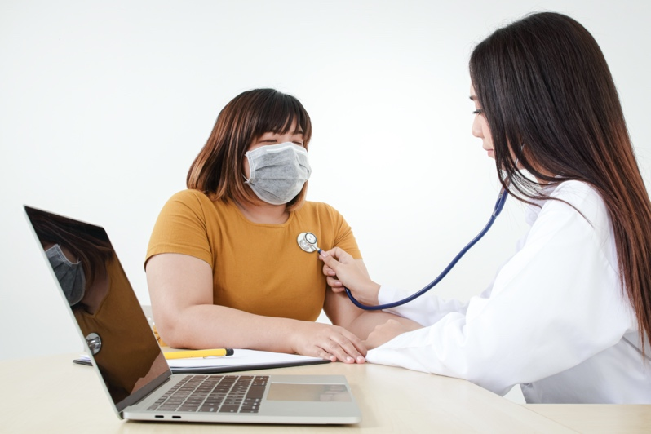
Image Link | https://www.shutterstock.com/image-photo/female-doctors-use-stethoscope-examine-heart-1694403451

Obesity is linked to a number of health risks, including heart disease, diabetes, stroke, and cancer. Experts are also finding that obesity is linked to severe COVID-19 complications and hospitalizations. A majority of patients that have been hospitalized, on a ventilator, or died due to COVID fell into the overweight or obese weight range. That’s why doctors and experts are recommending that individuals with obesity get the COVID-19 vaccination as soon as possible or pursue a weight-loss option, like bariatric surgery, to reach a normal weight.

Obesity Risk Factors Linked to COVID
Obesity is prevalent in the United States, and the number is on the rise. This could be one of the reasons the rate of COVID cases is so high in the United States compared to other countries. According to Dr. Jay Sizemore of the Erlanger Hospital infectious disease unit, an individual with obesity is more likely to experience “immune dysregulation.” This means that their immune systems may not work as effectively as individuals that fall into a healthier weight range. Additionally, their lung capacity may be limited, which means that they may be more likely to have to be put on a ventilator if they contract COVID. The virus enters the cells in the body and replicates. It enters the cells via a receptor called ACE2. There are more of these type of receptors in fat cells. According to Dr. Jaime Ponce, Medical Director of Bariatric Surgery at CHI Memorial, “They [individuals with obesity] have more of these receptors so the virus has the ability to get in to replicate and stay there more times.”

Preventing COVID
Individuals with obesity should get their COVID vaccinations as soon as possible to limit their chance of contracting the disease or from being hospitalized by the disease. While individuals wait to receive the vaccine, there are a few other things they can do to protect themselves in addition to social distancing. Enjoying healthy foods, drinking plenty of water, safely exercising regularly, getting enough sleep each night, and managing stress effectively will help keep your body healthy.

However, healthy lifestyle changes combined with weight-loss surgery produce the best results. While many hospitals have put off elective surgeries, there are weight-loss procedures, such as laparoscopic adjustable gastric band, that can be safely performed at an ambulatory (non-hospital) surgery center. So, while waiting for a lifesaving shot, people who are 30 - 60 pounds overweight have a proven solution available right now.

If you are ready to take control of your weight loss, the Lap-Band® Program may be the next step for you.

©2021 ReShape Lifesciences Inc All Rights Reserved

