Finding Success with LAP-BAND: Michelle’s Story

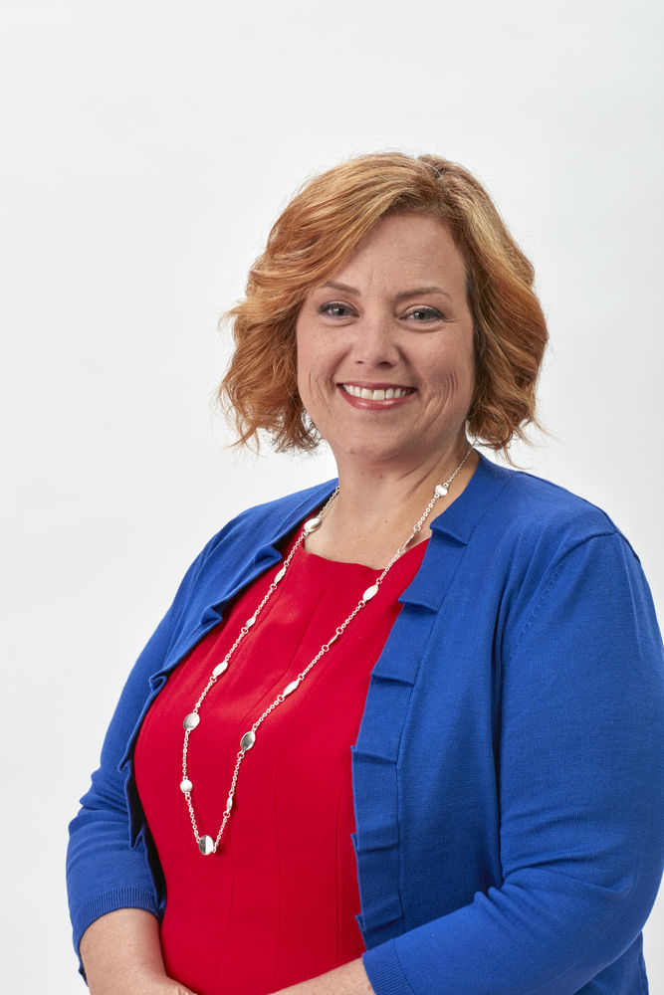

*Include video when uploading blog*
https://www.facebook.com/lapbandsystem/videos/554981491708837/

Countless individuals have found success with the LAP-BAND® Program. The procedure is performed laparoscopically, and there is no rerouting of the stomach or intestines, so patients are able to recover quickly and start their health journeys. The procedure is adjustable, which makes it a great option for many people who need to lose a significant amount of weight. Along with the procedure, aftercare programs that offer counseling, coaching, education, and support are proven to help achieve the best long-term weight loss results. Just take it from Michelle, who lost 162 pounds with the LAP-BAND System.

Making the Change
Michelle knew she needed to make a health change when she lost her husband to esophageal cancer. The numbers on the scale were climbing, and she feared for her life. She had two young children at the time, and she knew they couldn’t lose another parent. “It’s life or death for me,” she says. “I really believed it was, because I didn’t have a life before LAP-BAND.”

Choosing the Right Option
There are several bariatric procedures to choose from. However, unlike other options, LAP-BAND is both reversible and non-anatomy altering. “I chose LAP-BAND because I didn’t want any of my organs detached and reattached,” she says. The LAP-BAND is also adjustable, which has allowed Michelle to maintain her weight loss for six years.

Living a Better Life
With significant weight loss comes big life changes, and Michelle is no stranger to that. Many individuals notice improvement in comorbid conditions once they lose weight with LAP-BAND. They are able to enjoy their life again; their energy levels improve, they feel good about their body, and they are able to participate in activities they couldn’t for many years. Michelle knew it was a big deal when she realized she could sit comfortably in a chair again, fit in a restaurant booth, and ride on a rollercoaster.

Taking the Leap
Taking the first step is perhaps the most difficult one. “I know there are people out there that feel exactly the same way I did,” she says. You may feel like there is nothing that can help you or that you can’t make the change. “Yes, you can,” says Michelle. “If I can do it, you can do it.”

If you are in the Louisville, Kentucky area, visit www.lapbandoflouisville.com to meet with Michelle’s surgeons who offer the full LAP-BAND Program with state-of-the-art aftercare.

*Results and patient’s experiences may vary.

©2020 ReShape Lifesciences Inc All Rights Reserved Part Number 04-0579 Rev A

