Success Story Spotlight: Debbie
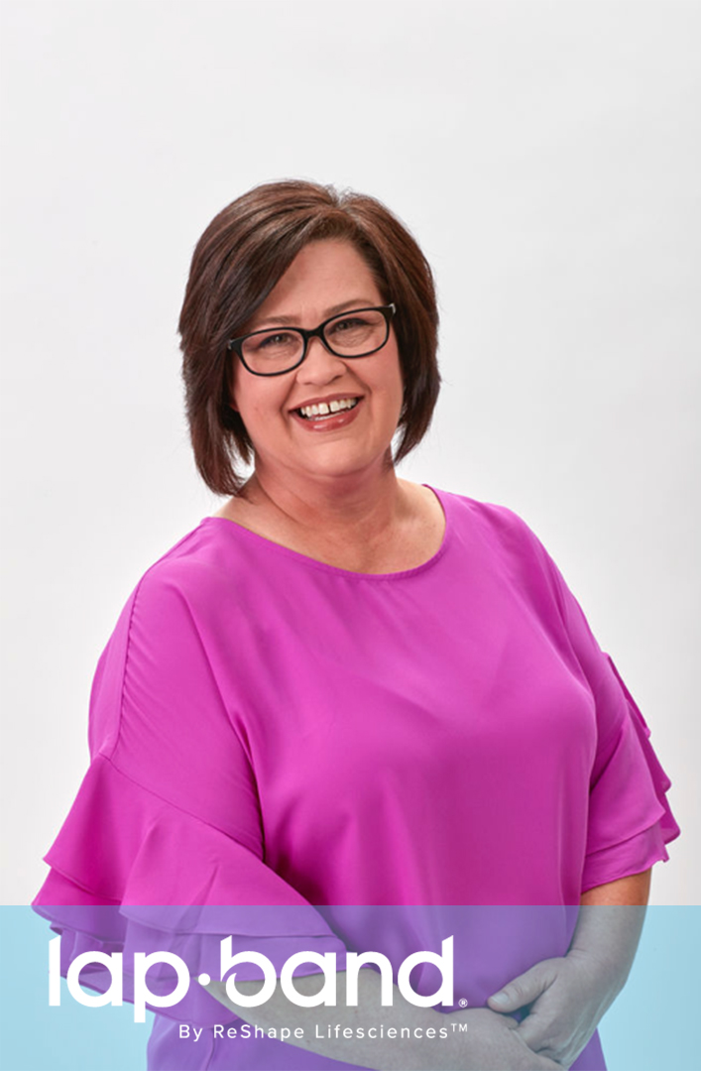

Have you tried to lose weight but you can’t seem to lose a pound? Or perhaps you have managed to lose weight following a new diet, but once you began to adjust to a normal eating plan, you gained all of the weight you lost and more. This story is all too relatable for countless individuals, Debbie included. She decided she was ready to take the leap and try the Lap-Band® Program, designed for individuals who have tried to lose weight multiple times but are unable to maintain long-term weight loss.

Growing Up
The pressure to lose weight is felt at a very young age by countless individuals, and it can have negative consequences. Debbie was told that “She’d be so cute if she lost a little bit of weight” growing up.

Choosing Lap-Band
“We’ve all been at the place where we’ve done diets,” Debbie says. While individuals can lose weight on diets, Debbie explained that “the weight tends to come back and every time you step on the scale it goes up.” Understanding she needed a little assistance, she decided to talk to a Lap-Band Specialist. “It was time for me to do this for myself,” she says. The Lap-Band Program was an attractive option because the surgery is performed laparoscopically as an outpatient procedure. Debbie was able to go home the same day as her procedure, allowing her to focus on healing and starting her weight-loss journey.

Seeing Results
Debbie lost 84 pounds in a year and a half with the Lap-Band Program, and she’s still going strong! One of her primary goals was to be able to go off her blood pressure and blood sugar medicine, and the Lap-Band Program helped her do that. The joy that she gets from seeing the scale drop a pound or two is indescribable.

Advice
Debbie describes the Lap-Band Program as a blessing. Even if you’re scared, like she was, she encourages you to talk to a specialist: “You will not regret your decision to have the Lap-Band Surgery.”

*Results and patients’ experiences may vary.

©2020 ReShape Lifesciences Inc All Rights Reserved Part Number 04-0689 Rev A

