The Problem with Skipping Meals for Weight Loss

Meta Description | The effects of skipping meals depend on each person. Is skipping meals bad for you and what are the potential issues when you skip your meal. Find out from Lap-Band.
Keywords | Effects of skipping meals, is skipping meals bad for you, skip your meal, skipping a meal, what does skipping meals do to you, dangers of skipping meals
Alt Tags | Concept of intermittent fasting
 | 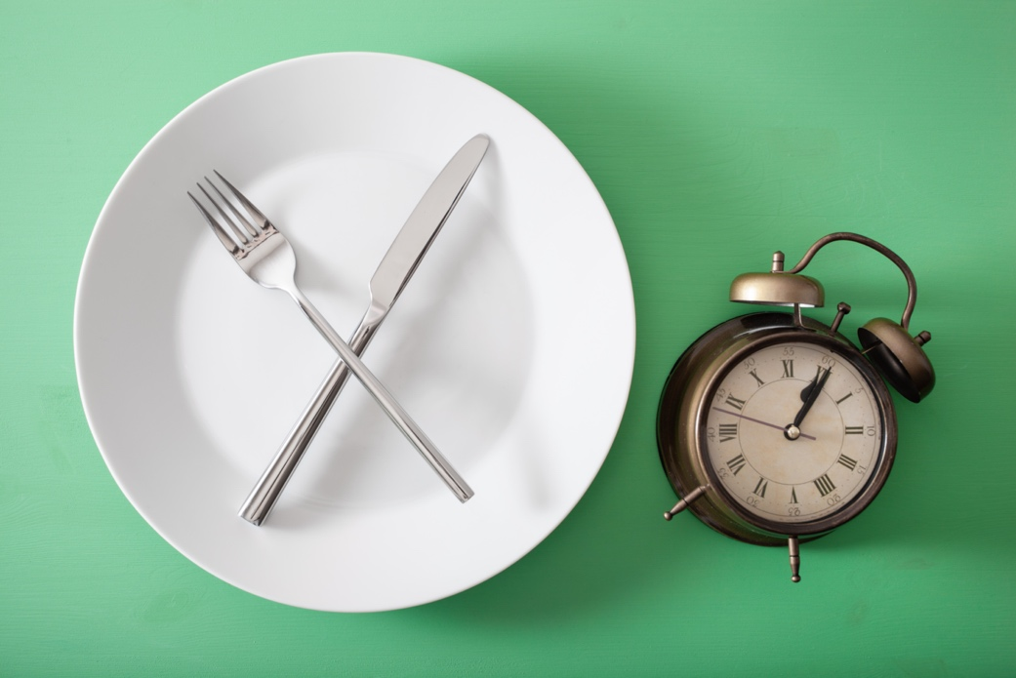
Image Link | https://elements.envato.com/concept-of-intermittent-fasting-ketogenic-diet-wei-VDEKVH8

Intermittent fasting is undoubtedly the newest trend in dieting and nutrition. While skipping a meal isn’t detrimental to your health, those trying to lose weight need to be aware of the dangers of skipping meals. While skipping meals and fasting intermittently can be good for your body, it can be detrimental if you alter your behavior in response.

The Rise of Skipping Meals
You’ve heard of intermittent fasting. People find the 16:8, 12:12, and 20:4 on their social feeds or from chatting with friends. With any new trend in health, it’s important to get a well-rounded view of the positives and negatives before weaving it into your lifestyle. Before we answer the question, “Is skipping meals bad for you?” we first should understand the effects of skipping meals and intermittent fasting.

Why People are Skipping a Meal
It’s important to know that the science of this practice is new. While people have been fasting for a long time for personal or religious reasons, the mechanisms surrounding fasting are still under observation. In preliminary studies, however, fasting has been shown to help control blood sugar, fight inflammation, and manage blood pressure.

The key debate involves the claims surrounding skipping meals and weight loss. Fasting can indeed put you at a caloric deficit, which enables weight loss. While this may sound like an easy win for those trying to lose weight it does come with some potential issues.

The Dangers of Skipping Meals
Fasting can also hinder your caloric intake. While the fasting mechanism is great for losing weight, some common resulting behaviors may cause you to reverse your progress.

First, it’s important to understand that intermittent fasting doesn’t enable you to eat more unhealthy foods. While the quantity of calories you get is important, the quality also matters. It’s not uncommon for those skipping meals to dine on unhealthy foods for the meals they do eat. Three, well-rounded meals might be replaced by a singular trip to your favorite fast-food restaurant. This behavior is more common than you might think and can lead to various nutrient deficiencies that stall your progress.

The second behavior you should know is the tendency to overeat. If you have a large appetite, it might be better to space out meals and snacks throughout the day. If you wait until one meal to satiate yourself, there is a chance that you’ll exceed your daily caloric intake in one sitting. You might think that this is extremely difficult, given the quantity of food you would need to eat. It’s important to remember that unhealthy foods are much more calorically dense. One trip to your favorite restaurant can total thousands of calories.

Lastly, adherence may also pose an issue. If you adopt any of these other behaviors and find that intermittent fasting isn’t right for you, you may be back to eating three unhealthy meals per day.

Don’t Sacrifice the Foods You Love
Losing weight shouldn’t require you to sacrifice the foods you love. If you want to skip meals, be sure you’re doing it solely for the health benefits. Many people fall into the trap of skipping three healthy meals in favor of one unhealthy meal, but this won’t lead to success. The key to lasting, effective weight loss is to enjoy the foods you love, but to do so in moderation.

For those who don’t know how to enjoy foods in moderation, the Lap-Band® Program can help. After receiving the Lap-Band, you will also receive expert care and guidance on how to enjoy a healthy lifestyle without sacrificing the foods you love. Get started by finding a Lap-Band surgeon near you.

