What Causes Obesity?

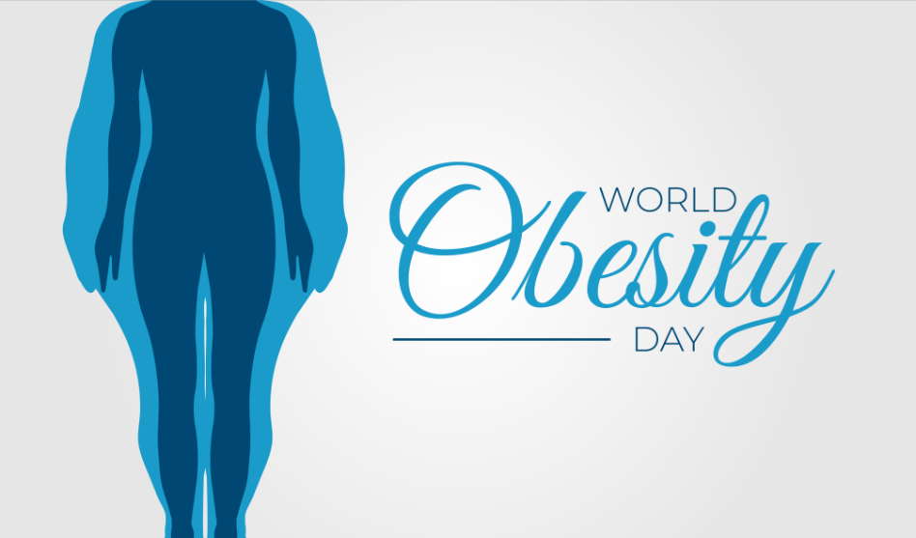

https://www.shutterstock.com/image-vector/world-obesity-day-background-illustration-1506817229

Each year on March 4, we recognize World Obesity Day. Recognized internationally, the day is designed to raise awareness about the obesity epidemic and provide individuals with obesity helpful information and resources. There is an unfair bias toward individuals with obesity and the false assumption that obesity is caused by factors entirely in our control, such as laziness and overeating. There are countless factors that play a role in the disease of obesity—many of which are not in our control.

Genetics
Genetics play a role in obesity. For example, if an individual’s parents both have obesity, the child is more likely to also struggle with obesity. The way fat is distributed and your metabolism are affected by genetics. We also learn eating and exercise habits from our families, meaning that individuals may be more likely to pick up unhealthy habits if they’re surrounded by them growing up.

Lack of Accessibility
The lack of accessibility to resources can play a role in obesity in more ways than one. This includes environmental, social, and economic factors. Some people do not have access to a safe environment that allows them the space to exercise. There may not be an accessible fitness center in town and there may not be sidewalks or bike trails. Other individuals do not have access to healthy foods, whether that is because they cannot afford healthy foods or because there is a lack of resources nearby. Many people do not have access to affordable health care to help them treat their obesity either. These same individuals may also not know how to cook healthy foods or have the resources to learn. This lack of resources is an unfortunate reality that many organizations, like the World Obesity Organization, are aiming to fix.

Illnesses and Medications
There is a whole list of illnesses and medications that can cause people to gain weight and struggle to lose it. Steroids and antidepressants, which are commonly prescribed, are linked to weight gain. Similarly, certain illnesses make exercising difficult, if not nearly impossible.

Lifestyle Choices
Making unhealthy food choices—such as eating a diet high in fat and sugar—or overeating can lead to weight gain. A sedentary lifestyle is also linked to weight gain. However, it is important to remember that this is not the only factor that contributes to obesity.

There are other factors that can make it more difficult for individuals to maintain a healthy weight, such as stress, poor sleep habits, and yo-yo dieting. To access weight-loss resources, visit our blog.

©2021 ReShape Lifesciences Inc All Rights Reserved Part Number 04-0783 Rev A

Meta Description: It is often assumed that obesity is caused by laziness and overeating. Learn more about the underlying factors that contribute to obesity.

